06 뷰 템플릿과 레이아웃

**뷰 템플릿과 레이아웃**

**미션**

뷰 템플릿 페이지에 헤더-푸터 레이아웃을 적용하시오.  
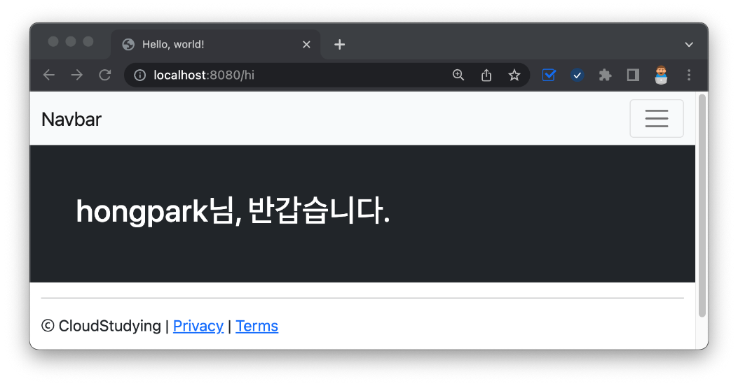

**부트스트랩 적용하기**

../resources/templates/greetings.mustache

1. <!doctype html>
2. <html lang="en">
3. <head>
4. <!-- Required meta tags -->
5. <meta charset="utf-8">
6. <meta name="viewport" content="width=device-width, initial-scale=1">
7. <!-- Bootstrap CSS -->
8. <link href="https://cdn.jsdelivr.net/npm/bootstrap@5.0.2/dist/css/bootstrap.min.css" rel="stylesheet" integrity="sha384-EVSTQN3/azprG1Anm3QDgpJLIm9Nao0Yz1ztcQTwFspd3yD65VohhpuuCOmLASjC" crossorigin="anonymous">
9. <title>Hello, world!</title>
10. </head>
11. <body>
12. <!-- navigation -->
13. <!-- content -->
14. <h1>{{username}}님, 반갑습니다.</h1>
15. <!-- site info -->
16. <!-- Optional JavaScript; choose one of the two! -->
17. <Script src="https://cdn.jsdelivr.net/npm/bootstrap@5.0.2/dist/js/bootstrap.bundle.min.js" integrity="sha384-MrcW6ZMFYlzcLA8Nl+NtUVF0sA7MsXsP1UyJoMp4YLEuNSfAP+JcXn/tWtIaxVXM" crossorigin="anonymous"></script>
18. </body>
19. </html>

**네브바 추가**

navbar 코드 블럭

1. <!-- navigation -->
2. <nav class="navbar navbar-expand-lg navbar-light bg-light">
3. <div class="container-fluid">
4. <a class="navbar-brand" href="#">Navbar</a>
5. <button class="navbar-toggler" type="button" data-bs-toggle="collapse" data-bs-target="#navbarSupportedContent" aria-controls="navbarSupportedContent" aria-expanded="false" aria-label="Toggle navigation">
6. <span class="navbar-toggler-icon"></span>
7. </button>
8. <div class="collapse navbar-collapse" id="navbarSupportedContent">
9. <ul class="navbar-nav me-auto mb-2 mb-lg-0">
10. <li class="nav-item">
11. <a class="nav-link active" aria-current="page" href="#">Home</a>
12. </li>
13. <li class="nav-item">
14. <a class="nav-link" href="#">Link</a>
15. </li>
16. <li class="nav-item dropdown">
17. <a class="nav-link dropdown-toggle" href="#" id="navbarDropdown" role="button" data-bs-toggle="dropdown" aria-expanded="false">
18. Dropdown
19. </a>
20. <ul class="dropdown-menu" aria-labelledby="navbarDropdown">
21. <li><a class="dropdown-item" href="#">Action</a></li>
22. <li><a class="dropdown-item" href="#">Another action</a></li>
23. <li><hr class="dropdown-divider"></li>
24. <li><a class="dropdown-item" href="#">Something else here</a></li>
25. </ul>
26. </li>
27. <li class="nav-item">
28. <a class="nav-link disabled" href="#" tabindex="-1" aria-disabled="true">Disabled</a>
29. </li>
30. </ul>
31. <form class="d-flex">
32. <input class="form-control me-2" type="search" placeholder="Search" aria-label="Search">
33. <button class="btn btn-outline-success" type="submit">Search</button>
34. </form>
35. </div>
36. </div>
37. </nav>

**하단 정보 넣기**

사이트 하단 코드 블럭

1. <!-- site info -->
2. <div class="mb-5 container-fluid">
3. <hr>
4. <p>ⓒ CloudStudying | <a href="#">Privacy</a> | <a href="#">Terms</a></p>
5. </div>

사이트 중단 코드 블럭

1. <!-- content -->
2. <div class="bg-dark text-white p-5">
3. <h1>{{username}}님, 반갑습니다.</h1>
4. </div>

**레이아웃 템플릿 생성 및 활용**

../templates/goodbye.mustache

1. {{>layouts/header}}
2. <div class="bg-dark text-white p-5">
3. <h1>{{nickname}}님, 다음에 또 만나요!</h1>
4. </div>
5. {{>layouts/footer}}

../templates/greetings.mustache

1. {{>layouts/header}}
2. <!-- content -->
3. <div class="bg-dark text-white p-5">
4. <h1>{{username}}님, 반갑습니다.</h1>
5. </div>
6. {{>layouts/footer}}

../templates/layouts/header.mustache

1. <!doctype html>
2. <html lang="en">
3. <head>
4. <!-- Required meta tags -->
5. <meta charset="utf-8">
6. <meta name="viewport" content="width=device-width, initial-scale=1">
7. <!-- Bootstrap CSS -->
8. <link href="https://cdn.jsdelivr.net/npm/bootstrap@5.0.2/dist/css/bootstrap.min.css" rel="stylesheet" integrity="sha384-EVSTQN3/azprG1Anm3QDgpJLIm9Nao0Yz1ztcQTwFspd3yD65VohhpuuCOmLASjC" crossorigin="anonymous">
9. <title>Hello, world!</title>
10. </head>
11. <body>
12. <!-- navigation -->
13. <nav class="navbar navbar-expand-lg navbar-light bg-light">
14. <div class="container-fluid">
15. <a class="navbar-brand" href="#">Navbar</a>
16. <button class="navbar-toggler" type="button" data-bs-toggle="collapse" data-bs-target="#navbarSupportedContent" aria-controls="navbarSupportedContent" aria-expanded="false" aria-label="Toggle navigation">
17. <span class="navbar-toggler-icon"></span>
18. </button>
19. <div class="collapse navbar-collapse" id="navbarSupportedContent">
20. <ul class="navbar-nav me-auto mb-2 mb-lg-0">
21. <li class="nav-item">
22. <a class="nav-link active" aria-current="page" href="#">Home</a>
23. </li>
24. <li class="nav-item">
25. <a class="nav-link" href="#">Link</a>
26. </li>
27. <li class="nav-item dropdown">
28. <a class="nav-link dropdown-toggle" href="#" id="navbarDropdown" role="button" data-bs-toggle="dropdown" aria-expanded="false">
29. Dropdown
30. </a>
31. <ul class="dropdown-menu" aria-labelledby="navbarDropdown">
32. <li><a class="dropdown-item" href="#">Action</a></li>
33. <li><a class="dropdown-item" href="#">Another action</a></li>
34. <li><hr class="dropdown-divider"></li>
35. <li><a class="dropdown-item" href="#">Something else here</a></li>
36. </ul>
37. </li>
38. <li class="nav-item">
39. <a class="nav-link disabled" href="#" tabindex="-1" aria-disabled="true">Disabled</a>
40. </li>
41. </ul>
42. <form class="d-flex">
43. <input class="form-control me-2" type="search" placeholder="Search" aria-label="Search">
44. <button class="btn btn-outline-success" type="submit">Search</button>
45. </form>
46. </div>
47. </div>
48. </nav>

../templates/layouts/footer.mustache

1. <!-- site info -->
2. <div class="mb-5 container-fluid">
3. <hr>
4. <p>ⓒ CloudStudying | <a href="#">Privacy</a> | <a href="#">Terms</a></p>
5. </div>
6. <!-- Optional JavaScript; choose one of the two! -->
7. <Script src="https://cdn.jsdelivr.net/npm/bootstrap@5.0.2/dist/js/bootstrap.bundle.min.js" integrity="sha384-MrcW6ZMFYlzcLA8Nl+NtUVF0sA7MsXsP1UyJoMp4YLEuNSfAP+JcXn/tWtIaxVXM" crossorigin="anonymous"></script>
8. </body>
9. </html>

**🔥 구글링 훈련하기**

* 부트스트랩이란
* 머스테치 partial view